Slow sink

Graphs for CPI medium post

* 20 year major components
* 20 year Alcohol, tobacco, cannabis components
* 20 year shelter components
* 3 year major components
* 3 year shelter components

Recently there has been substantial media attention on large increases in the price of houses, lumber, and, earlier during COVID, beef and pork. Focus tends to be on the increase in prices of individual products, rather than how prices are changing overall across the economy. I thought it would be useful to take a longer and broader view to see how prices have changed over the past 20 years in Canada.

The All-items CPI is the measure that the Bank of Canada’s inflation target is based on. The Bank conducts monetary policy operations (interest rate setting, Quantitative Easing) to try and keep the annual percentage change of the All-items CPI to be between 1 and 3%. The CPI is a price index based on the prices of a fixed basket of goods and services where the fixed basket is informed by data from the Survey of Household Spending. It reflects the price level across the economy, and somewhat the cost of living, though it is not a true cost of living index since the basket is fixed. Also, the CPI may not reflect your individual cost of living because your basket may look different than the CPI basket. They do update the basket every two years, and use techniques to link them together across time.

The figure below shows how the prices of the eight major product components of the CPI changed over the past 20 years. It might surprise you (or not surprise you if you are a smoker!) that the prices of Alcohol, tobacco, and legal cannabis increased the most. Though this component only represents around 3% of the CPI basket. The drastic increase in this component is completely driven by Tobacco prices (including increased tobacco taxes), whereas the price of alcoholic beverages has increased at a similar rate to the All-items CPI.

The prices of Food, Shelter and, Transportation also increased more than the overall CPI. And given their respective weights in the CPI (around 15%, 27%, 20%), these are the components that have been driving the increase in the CPI over the past 20 years.

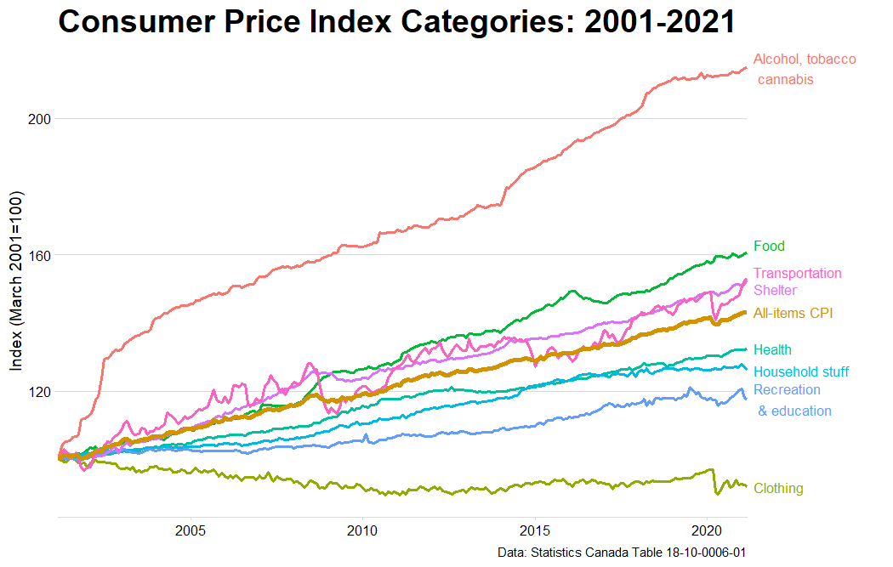

One interesting aspect from the figure, is that the prices of clothing and footwear didn’t just decline compared to the prices of everything else (the All-items CPI), they declined in absolute terms! $100 today buys more clothes and footwear than $100 did in 2001! This is despite $100 today being able to buy much less of everything else than $100 did in 2021. Globalization has given us cheaper clothes and footwear, and this makes Canadian consumers better off. That said, clothing and footwear are only about 5-6% of the cost of the basket.

People and the media seem to focus on the prices of some individual products that go into the CPI, house prices for example, but ignore other aspects of shelter costs. In the CPI, measuring ‘shelter’ costs encompasses all ways people buy shelter, e.g., rent, buy a house and then implicitly buy shelter from the house, or implicitly buy shelter from the house they already partially own. So, drastically increasing house prices are muted in the shelter component since only a small percentage of the housing stock is sold each month. This is very confusing because the implicit price of the shelter provided by owner occupied homes is calculated much differently than other consumer goods in the CPI (more information can be found here: <https://www150.statcan.gc.ca/n1/pub/62-553-x/2019001/chap-10-eng.htm>). The Shelter component of the CPI can be broken into the Rented Accommodation, Owned Accommodation, and Utilities. 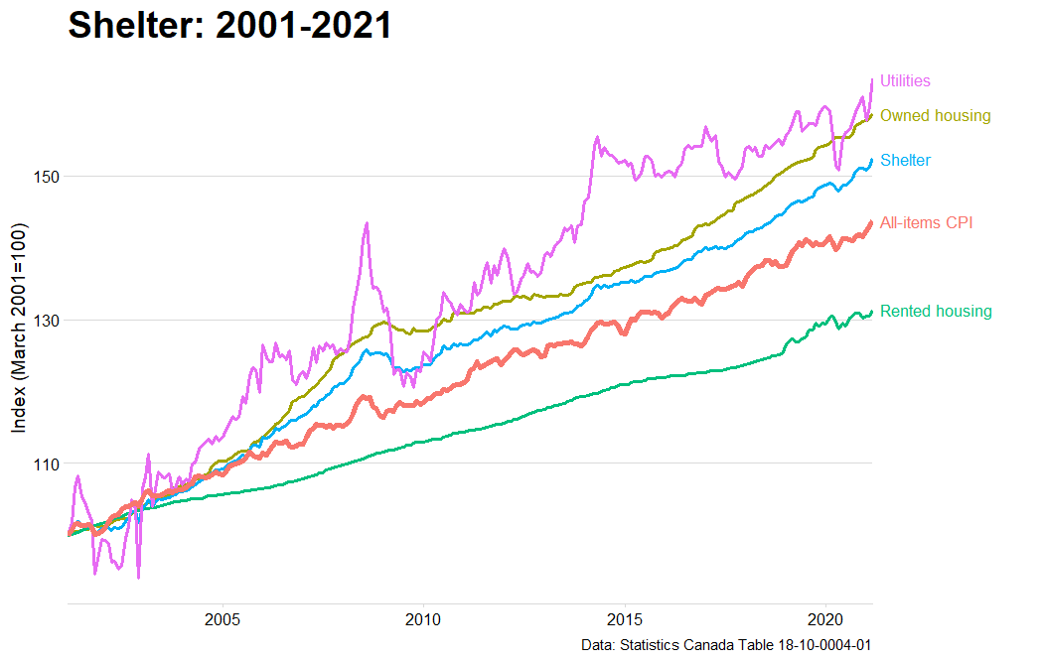

The increased price of Shelter, above the All-items CPI, is due to the increased price of shelter from Owned Accommodation and Utilities, whereas the cost of Rental Accommodation increased less than the All-items CPI.

The Owned Accommodation sub-component can be further broken down in the figure below. Home and Mortgage Insurance costs have increased drastically over the past 20 years; this isn’t surprising since mortgage insurance premiums would be connected to house prices. Whereas, low interest rates have meant that Mortgage Interest Costs have barely increased over the 20 year period. For someone lucky enough to have bought a house already, they have probably seen their monthly mortgage payments decline as interest rates declined.

